The main aim of this presentation is to understand the general terms which are widely used in air-conditioning industry which allow us for more precise communication.
Most commonly used terms in air-conditioning are as follows:
- Refrigeration Cycle
- Evaporation
- Compression
- Condensation
- Refrigerant
- Cooling Capacity

Refrigeration Cycle
Closed cycle of evaporation, compression and condensation which results in transferring heat energy away from one environment to other environment. Refrigerant changes its state form liquid to gas and then again to liquid each time it travels the various components of an air-conditioning system.

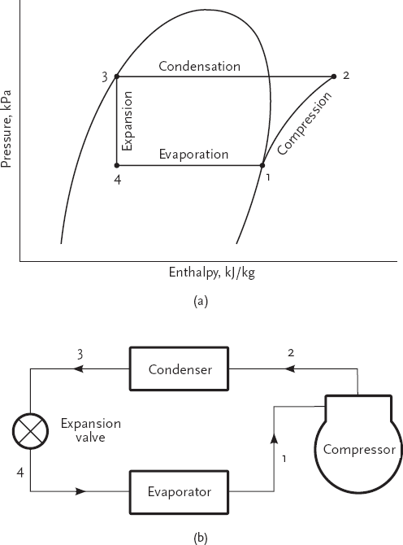

Equipment involved in the refrigerant cycle along with processes are placed next to each other in order to give a proper idea.
Evaporation
The process of liquid becoming gas (Vapor) is called evaporation. The evaporator coil is essential for this process in an air-conditioning system and its usually found inside the space from where we need to remove heat from. This part of the system gets cold to the touch (about 7°C/ 45°F) during it’s operation.
Compression
The process of reducing the volume of a vapor or gas is called compression. This process results in high pressure and temperature to the refrigerant leaving the compressor.
Condensation
An air-conditioner condensing unit works by turning gaseous refrigerant into liquid state. This process of gas turning into liquid state is called condensation. The condenser coil is usually located outside the space from where we need to remove heat from. It allows refrigerant to transfer heat without mixing.

Refrigerant
Refrigerant/ Freon is the fluid made of hydro flouro carbons (HFCs) which helps in rapid transfer of heat. Refrigerant can turn into liquid from vapour state at high pressure and liquid refrigerant turns into gaseous state at lower temperature/ pressure. Most commonly used refrigerants in air-conditioning industry as per their applications are as listed in the below table:
Application | Refrigerant Name
Automobiles ACs | R134a
Commercial ACs | R410a
Residential ACs | R32

Cooling Capacity
Cooling capacity is the measurement of a cooling system (Air-conditioner) and its ability to remove heat from a specific space.
A BTU is defined as the amount of heat energy required to raise the temperature of one pound of water by one degree Fahrenheit in one hour.
The term "ton" refers to the approximate amount of cooling power that a ton of ice would provide if it melted over a 24-hour period. One ton is equal to 12,000 BTU/hr.
Universally it is measured in watts.

